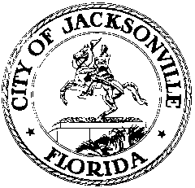

**OFFICE OF THE CITY COUNCIL**

**CHERYL L. BROWN** 117 WEST DUVAL STREET, SUITE 425

DIRECTOR 4TH FLOOR, CITY HALL

OFFICE (904) 630-1452 JACKSONVILLE, FLORIDA 32202

FAX (904) 630-2906

E-MAIL: CLBROWN@coj.net

**SPECIAL BUDGET ANALYSIS COMMITTEE MINUTES**

**February 20, 2014**

**3:00 p.m.**

**City Hall**

**117 W. Duval St., 1st Floor**

**Committee Room B**

**Attendance:** Council Members Clay Yaraborough (Chair), Matt Schellenberg, Reggie Brown, Warren Jones, Robin Lumb, Don Redman

**Excused:** Richard Clark

**Also**: Kirk Sherman – Council Auditor’s Office;Carol Owens and Philip Zamarron – Legislative Services Division; Yvonne Mitchell – Council Research

See attached sign-in sheet for additional attendees.

Council Member Yaraborough called the meeting to order at 3:04 p.m. He reviewed the committee scheduled and explained the charge of the committee. This process will be very similar to budget review with the exception that it will be looking from a zero bases. An email will be sent to all department heads about the charge and information required for their presentation.

Mr. Sherman distributed a copy of the Council Auditor’s Office 2013/14 Budget Summary Special Report #742 and provided a thorough analysis of the executive summary. Additionally, Mr. Sherman provided a revised copy of the committee meeting schedule to include book page references to summary of the annual budget.

The next meeting is scheduled for March 6th at 2:00 p.m. There being no further business, the meeting was adjourned at 4:53p.

Yvonne P. Mitchell, Council Research Division (904) 630-1679

Posted 03.4.14 12:00 p.m.